SECTION IV

BIOLOGICAL STATISTICS

1. Hypothesis testing is a predictional analysis used to infer the results of the hypothesis performed on a sampled data from a larger population. In other words, hypothesis is an assumption which is tested to determine the relationship between two data sets.

Types of hypothesis testing : Simple,complex, empirical, null, alternative, Logical and statistical.

It could be used for extracting information about the population parameter which could be used for verification and analysis.

1. Correlation is a statistical technique which tells about the linear relationship between two quantitiative variables. It can show whether and how strongly pairs of variables are related.

When the value of one variable increase as the other increases, then it is referred to be positive correlation and the reversal of this process is negative correlation.

1. Methods to compute correlation:

* Graphical method – simple graph and scatter method
* Karl Pearson’s coefficient of correlation method
* Spearman’s coefficient of correlation method(Rank method)
* Concurrent deviations method

1. The p-value or the probability value is the level of marginal significance within a statistical hypothesis test representing the probability of the occurrence of a given event. The p-value is computed using the sampling distribution of the test statistic under the null hypothesis, sample data and the type of test being performed(lower-tailed test, upper-tailed test or two tailed test)
2. a) Mean= 47.75

variance= 58.5

standard deviation= 7.15

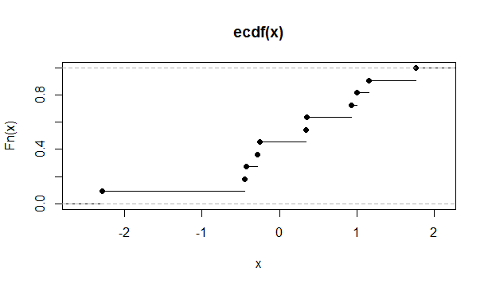

Empirical distribution function of the data

(b) 25% quantile =42.5

50% quantile = 49

75% quantile = 53.5

Median= 49

1. i)Estimates of mean (µ) = 173.1 and variance(𝜎2) = 610.89